**Assignment 04**

**Port Discovery Techniques**

**CS4061**

**Ethical Hacking Concepts and Practices**

**Submitted by:** Faizan Pervaz

**Roll number:** 20I-0565

**Date:** 24-03-2024

**Table of Contents**

• **Introduction** 4

• **Steps** 4

**1. ICMP Ping Scan** 4

**2. UDP Ping Scan** 5

**3. TCP Scans** 6

**1.** **SYN Scan (Full Open Scan)** 6

**2.** **Stealth Scan (Half Open Scan)** 8

**3.** **Inverse TCP Flag Scan** 8

1. **FIN Scan** 11
2. **Null Scan** 11
3. **XMAS Scan** 12
4. **Maimon Scan** 13

**3.** **ACK Flag Scan** 14

1. **TTL Based Scan** 15
2. **Window Scan** 16

• **Summary** 16

• **References** 17

# **Introduction**

# Network scanning is a fundamental aspect of ethical hacking, enabling practitioners to identify open ports and potential vulnerabilities within target systems. In this report, we explore various port discovery techniques using tools such as Nmap, Hping, and Scapy. Each technique serves to uncover information about the services running on a target system, aiding in vulnerability assessment and penetration testing.

# **Steps**

# **1. ICMP Ping Scan**

# Command: nmap -sn 192.168.100.117

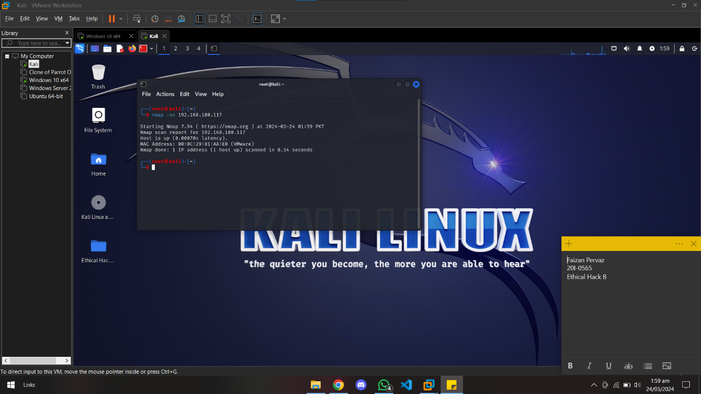

* Description: ICMP Ping Scan is a host discovery technique that sends ICMP echo requests to a target system without scanning ports. It determines whether a host is active based on ICMP responses. This technique is useful for quickly identifying active hosts on a network without generating extensive traffic or triggering security alerts.
* Command: nmap -PE -p 80,443 <target>

nmap -PE -p 445,5357 192.168.100.117

* Description:
  + -PE indicates that Nmap should perform an ICMP Echo Ping Scan, sending ICMP Echo Request packets to the target.
  + -p 80,443 specifies the ports to be "scanned" (in this case, ports 80 and 443, commonly used for HTTP and HTTPS).
  + <target> represents the IP address or hostname of the target system.

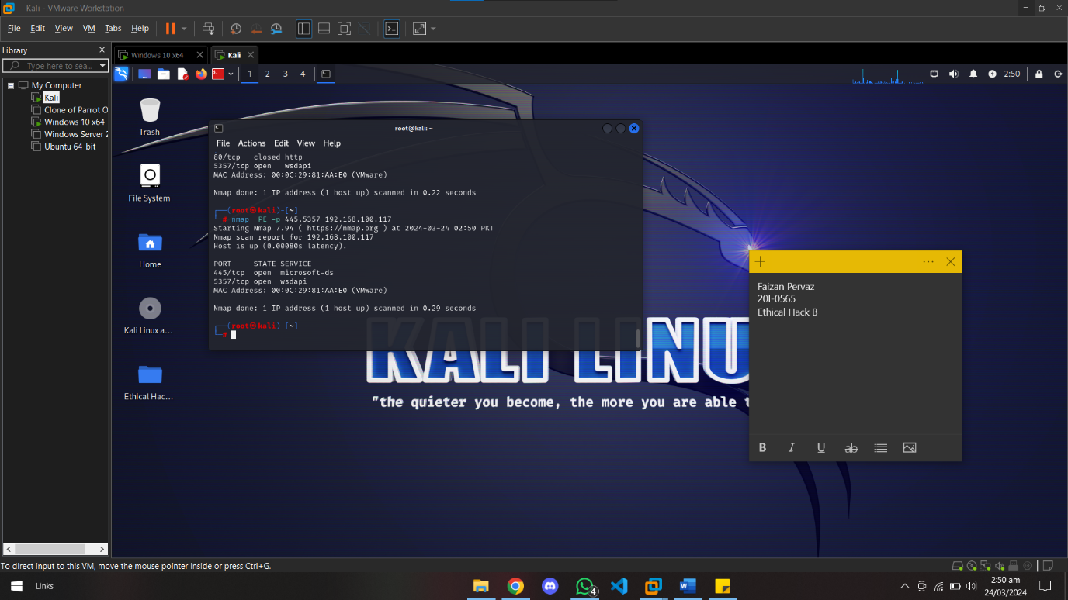

# **2. UDP Ping Scan**

# Command: nmap -PU 192.168.100.117

# Description: UDP Ping Scan probes target systems by sending UDP packets to specified ports and analyzing responses. It helps identify active hosts that respond to UDP packets, providing insights into potential services running on those hosts. UDP Ping Scans are particularly useful for discovering hosts that may not respond to ICMP requests.

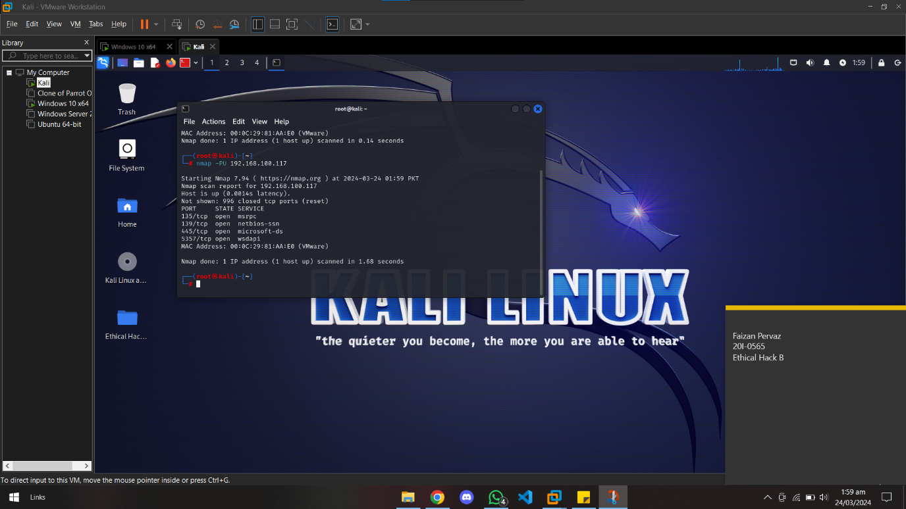

# **3. TCP Scans**

# **SYN Scan (Full Open Scan)**

# Command: nmap -sS 192.168.100.117

# Description: SYN Scan, also known as Full Open Scan, sends SYN packets to target ports and analyzes responses to determine port state. It identifies open ports by examining SYN/ACK responses, closed ports by RST responses, and filtered ports by no response.

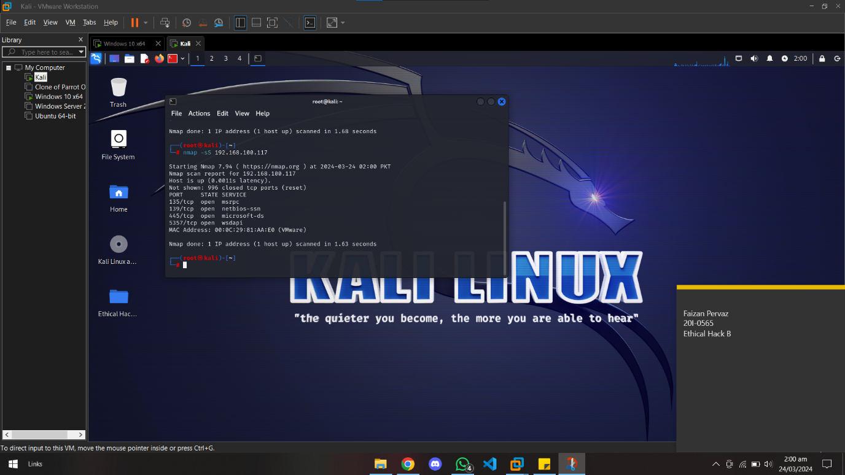

# Command: nmap -sS -p <port> <target>

nmap -sS -p 5357 192.168.100.117

# Description: SYN Scan, also known as Full Open Scan, sends SYN packets to target ports and analyzes responses to determine port state. It identifies open ports by examining SYN/ACK responses, closed ports by RST responses, and filtered ports by no response.

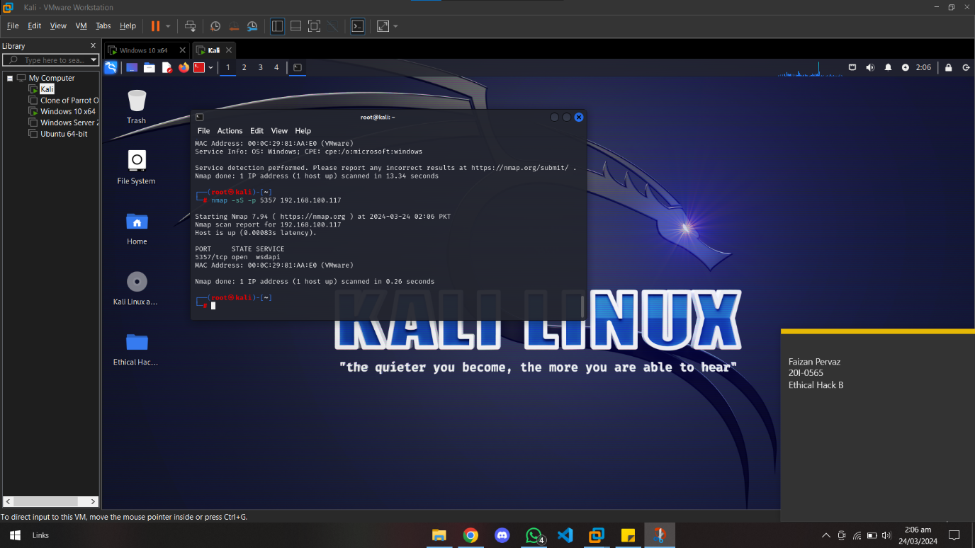

# **Stealth Scan (Half Open Scan)**

# Command: nmap -sS 192.168.100.117

# Description: Stealth Scan, a variation of SYN Scan, sends SYN packets to target ports but does not complete the TCP handshake. It helps avoid logging on target systems and is effective for stealthy reconnaissance.



* Command: nmap -sS -sV 192.168.100.117
* Description: The Stealth Scan, also known as the Half Open Scan, combines SYN scanning (-sS) with service version detection (-sV) in Nmap. It sends SYN packets to target ports, analyzing responses to determine open ports and identifying services running on them without completing the TCP handshake. This technique enhances stealth and efficiency in network reconnaissance for ethical hacking and security assessments.

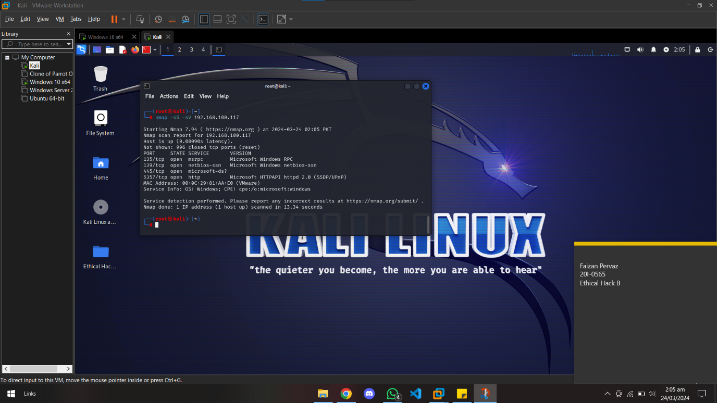

1. **Inverse TCP Flag Scans**
2. **FIN Scan**

* Command: nmap -sF 192.168.100.117
* Description: FIN Scan sends TCP packets with the FIN flag set to target ports and analyzes responses. It aims to determine port state based on different responses from open, closed, and filtered ports.

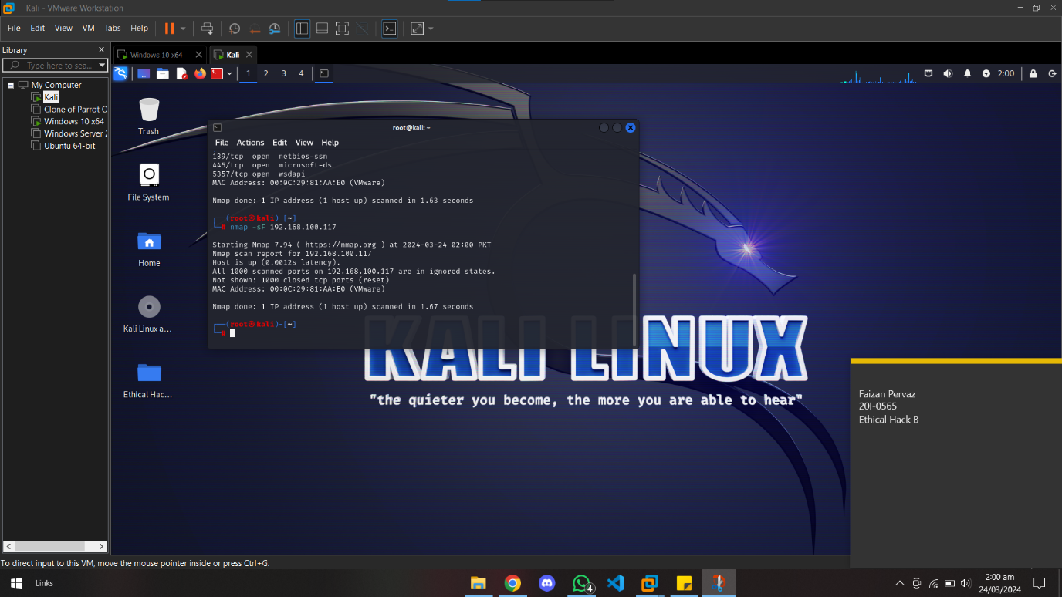

# **Null Scan**

# Command: nmap -sN 192.168.100.117

# Description: Null Scan sends TCP packets with no flags set to target ports and analyzes responses. It relies on differences in responses from open and closed ports to determine port state.

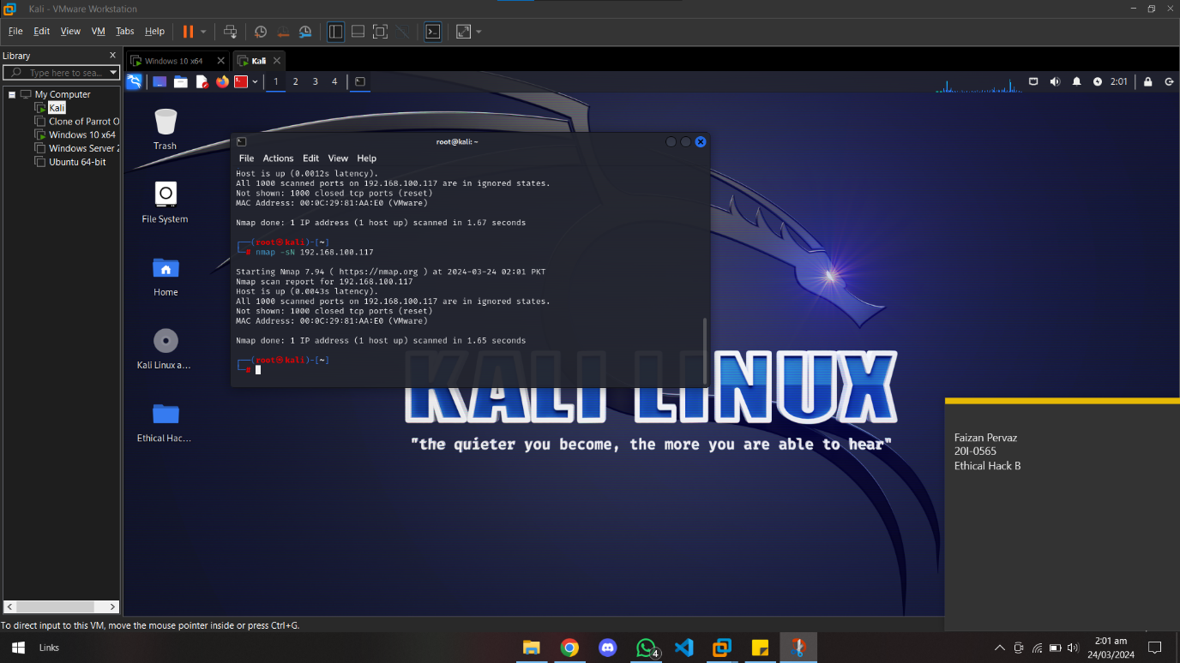

# **XMAS Scan**

# Command: nmap -sX 192.168.100.117

# Description: XMAS Scan sends TCP packets with various flags (FIN, URG, PSH) set to target ports and analyzes responses. It exploits differences in responses to identify open, closed, and filtered ports.

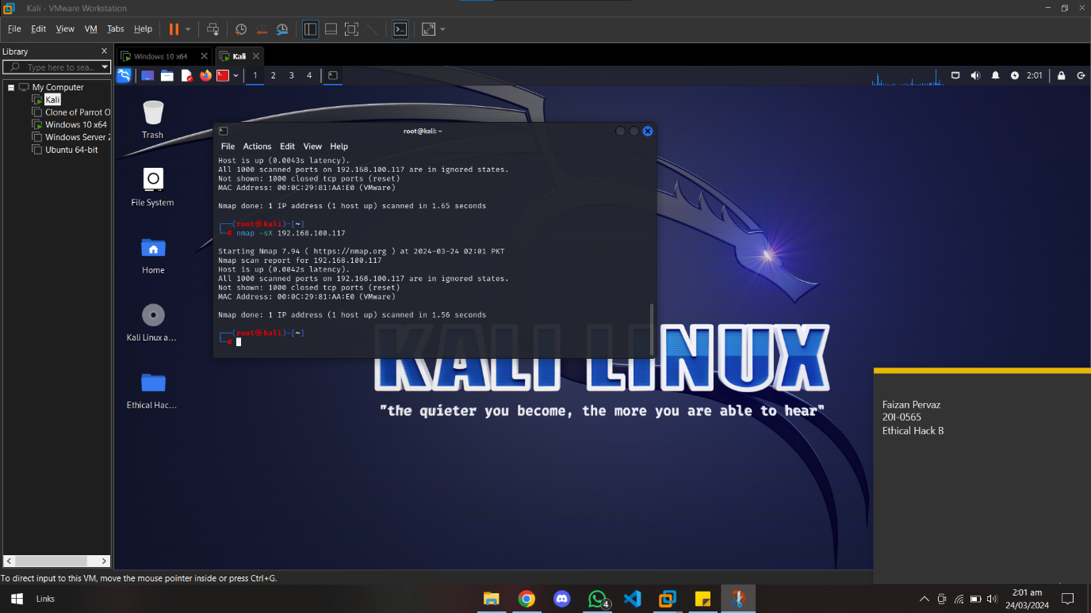

# **Maimon Scan**

# Command: nmap --scanflags FINACK 192.168.100.117

# Description: Maimon Scan is a specialized scan that sets the FIN and ACK flags in TCP packets. It aims to bypass firewall rules and intrusion detection systems by mimicking legitimate traffic.

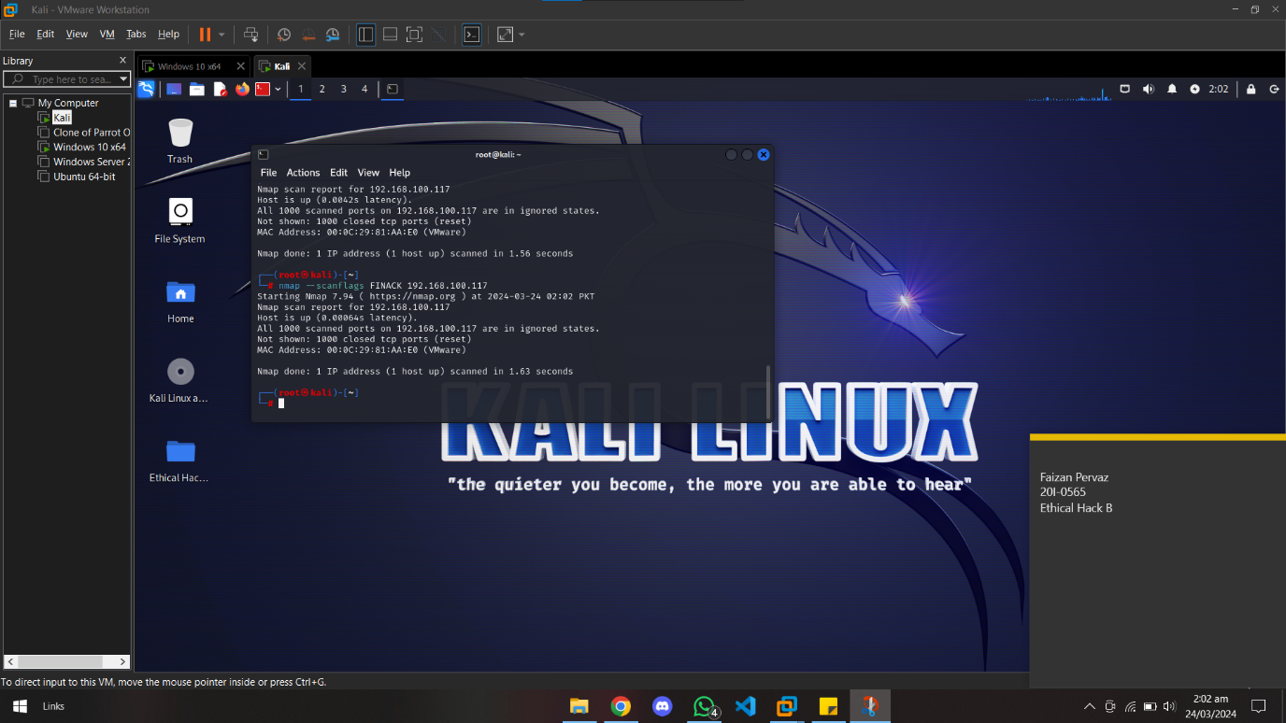

# **ACK Flag Scan**

# Command: nmap -sA 192.168.100.117

# Description: ACK Flag Scan sends TCP packets with the ACK flag set to target ports and analyzes responses, focusing on the Time-To-Live (TTL) value in responses to infer information about the target system's operating system.

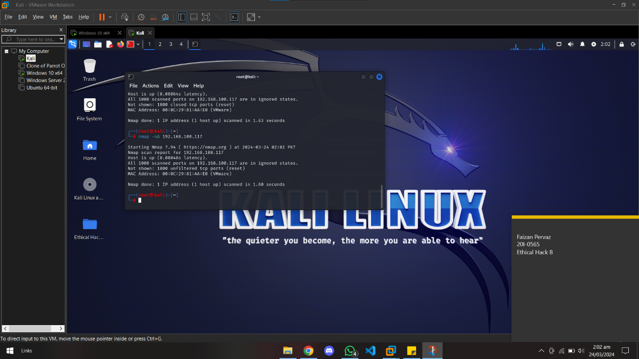

# **TTL Based Scan**

# Command: nmap --ttl <value> <target>

nmap --ttl 10 192.168.100.117

# Description: The TTL Based Scan in Nmap allows users to specify a custom Time-To-Live (TTL) value in outgoing packets to analyze responses from target systems. By manipulating TTL values and observing responses, this technique aids in OS fingerprinting, helping to identify target operating systems and assess network diversity for penetration testing and security analysis.

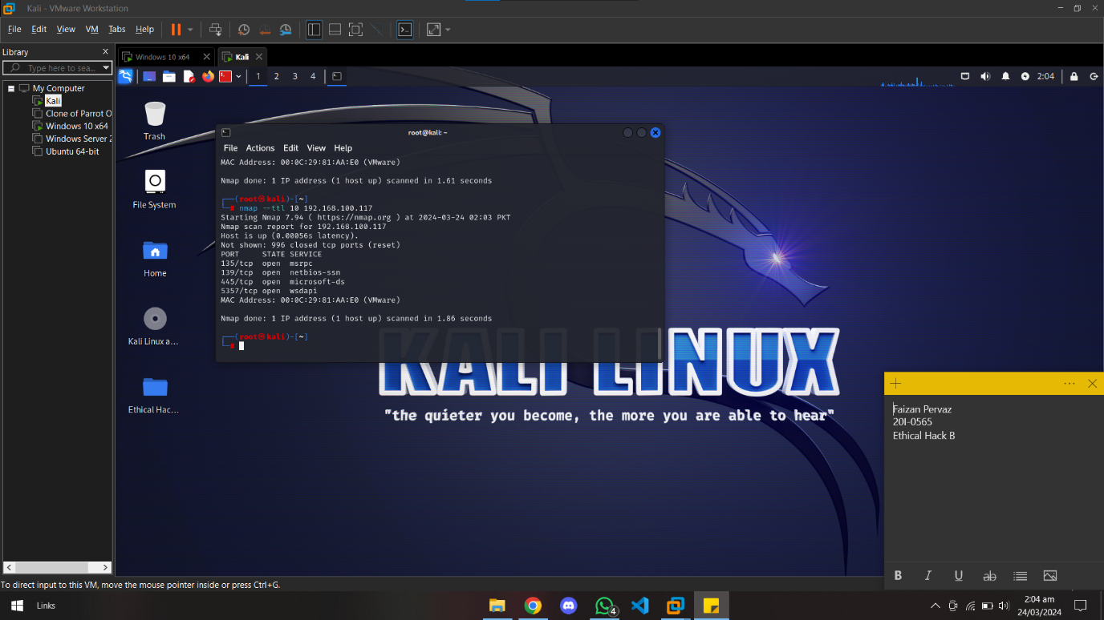

# **Window Scan**

# Command: nmap -sW 192.168.100.117

# Description: Window Scan sends TCP packets with the ACK flag set and window size manipulated to target ports. It helps identify open ports by analysing TCP window size responses.

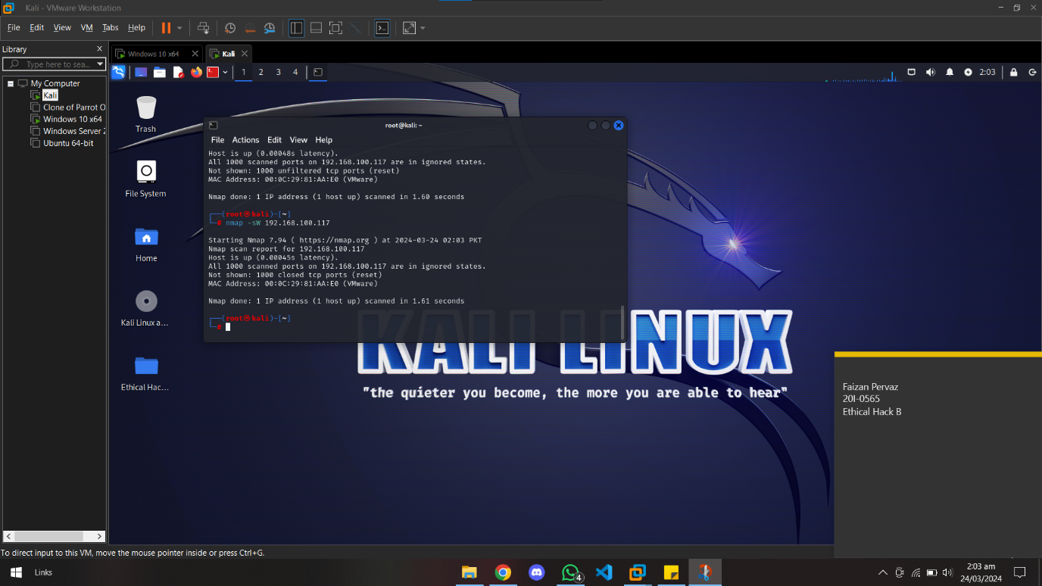

# **Summary**

Port discovery techniques are essential components of network reconnaissance in ethical hacking. By leveraging tools such as Nmap, Hping, and Scapy, practitioners can gather valuable information about target systems, including active hosts and open ports. Understanding the nuances of each scanning technique enables ethical hackers to conduct thorough vulnerability assessments and enhance overall network security.

# **References**

1. <https://nmap.org/book/man-port-scanning-techniques.html>
2. <https://nmap.org/book/scan-methods-null-fin-xmas-scan.html>
3. <https://www.stationx.net/nmap-cheat-sheet/>
4. <https://nmap.org/book/port-scanning-tutorial.html>